## 2.1 Basic Theory & Working Principle

INTRODUCTION:-

The internet of things, or IoT, is a system of interrelated computing devices, mechanical and digital machines, objects, animals, or people that are provided with unique identifiers (UIDs) and the ability to transfer data over a network without requiring human-to-human or human-to-computer interaction.

A thing in the internet of things can be a person with a heart monitor implant, a farm animal with a biochip transponder, an automobile that has built-in sensors to alert the driver when tire pressure is low or any other natural or man-made object that can be assigned an Internet Protocol (IP) address and can transfer data over a network.

Increasingly, organizations in a variety of industries are using IoT to IoT more efficiently, better understanding customers to deliver enhanced customer service, improve decision-making and increase the value of the business.

**WORKING PRINCIPLE:-**

An IoT ecosystem consists of web-enabled smart devices that use embedded systems, such as processors, sensors, and communication hardware, to collect, send and act on data they acquire from their environments. IoT devices share the sensor data they collect by connecting to an IoT gateway or other edge device where data is either sent to the cloud to be analyzed or analyzed locally. Sometimes, these devices communicate with other related devices and act on the information they get from one another. The devices do most of the work without human intervention, although people can interact with the devices -- for instance, to set them up, give them instructions or access the data.

The connectivity, networking, and communication protocols used with these web-enabled devices largely depend on the specific IoT applications deployed.

Iot can also make use of artificial intelligence (AI) and machine learning to aid in making data collecting processes easier and more dynamic.

## 2.2. Block & Circuit Diagram

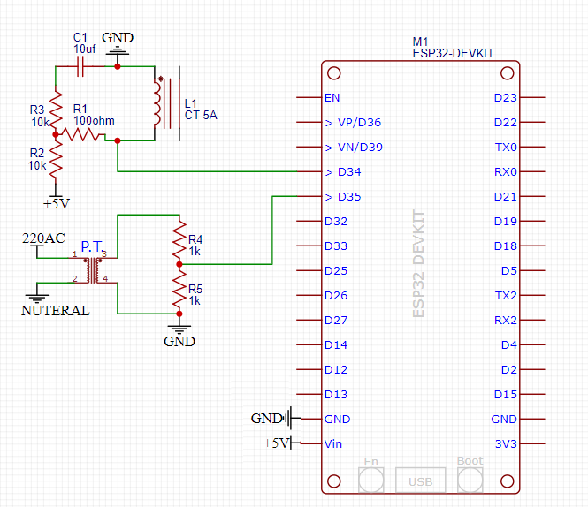

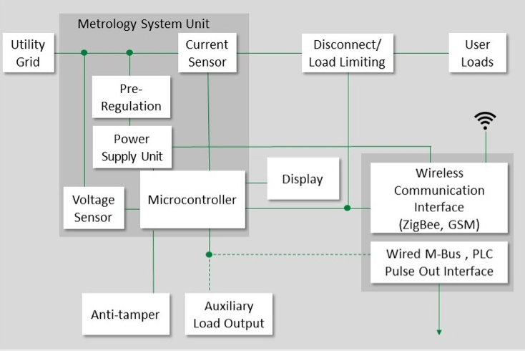

### ESP-WROOM-32: -

ESP32 is a series of the low-cost, low-power system on a chip microcontroller with integrated Wi-Fi and dual-mode Bluetooth. The ESP32 series employs both a Tensilica Xtensa LX6 microprocessor in both dual-core and single-core variations, Xtensa LX7 dual-core microprocessor, and a single-core RISC-V microprocessor and includes built-in antenna switches, RF balun, power amplifier, and low-noise receive amplifier, filters, and power management modules. ESP32 is created and developed by Espressif Systems, a Shanghai-based Chinese company, and is manufactured by TSMC using their 40 nm process. It is a successor to the ESP8266 microcontroller.

Specification:-

Power= 3.3V DC

CPU= Tensilica LX6 microprocessor @ 160 or 240 MHZ

Memory= 520 KB of SRAM and support for both classic Bluetooth V4.2 and BLE specifications.

### Potential Transformer:-

  The potential transformer is defined as an instrument transformer used for the transformation of voltage from a higher value to a lower value. This transformer step down the voltage to a safe limit value which can be easily measured by the ordinary low voltage instrument like a voltmeter, wattmeter and watt-hour meters, etc. It is connected in parallel with the circuit.

### Current transformer:-

A current transformer is a device that is used for the transformation of current from a higher value into a proportionate current to a lower value. It transforms the high voltage current into the low voltage current due to which the heavy current flows through the transmission lines are safely monitored by the ammeter. It is connected with the circuit in series.

### Resistors:-

A resistor is a passive two-terminal electrical component that implements electrical resistance as a circuit element.In electronic circuits, resistors are used to reduce current flow, adjust signal levels, divide voltages, bias active elements, and terminate transmission lines, among other uses.High-power resistors that can dissipate many watts of electrical power as heat, may be used as part of motor controls, in power distribution systems, or as test loads for generators. Fixed resistors have resistances that only change slightly with temperature, time, or operating voltage. Variable resistors can be used to adjust circuit elements (such as volume control or a lamp dimmer), or as sensing devices for heat, light, humidity, force, or chemical activity. Its unit is ohms. It is denoted by ‘R’.

1. **Capacitor:-**

**The capacitor is a** device for storing electrical energy, consisting of two conductors near and insulated from each other. A simple example of such a storage device is the parallel-plate capacitor. If positive charges with total charge +Q are deposited on one of the conductors and an equal amount of negative charge −Q is deposited on the second conductor, the capacitor is said to have a charge Q. Its unit is Farad. It is denoted by “C”.

Capacitors have many important applications. They are used, for example, in digital circuits so that information stored in large computer memories is not lost during a momentary electric power failure; the electric energy stored in such capacitors maintains the information during the temporary loss of power. Capacitors play an even more important role as filters to divert spurious electric signals and thereby prevent damage to sensitive components and circuits caused by electric surges.

Specification:-

10 microfarad 1 piece

**4.3. Collecting project components and tools**

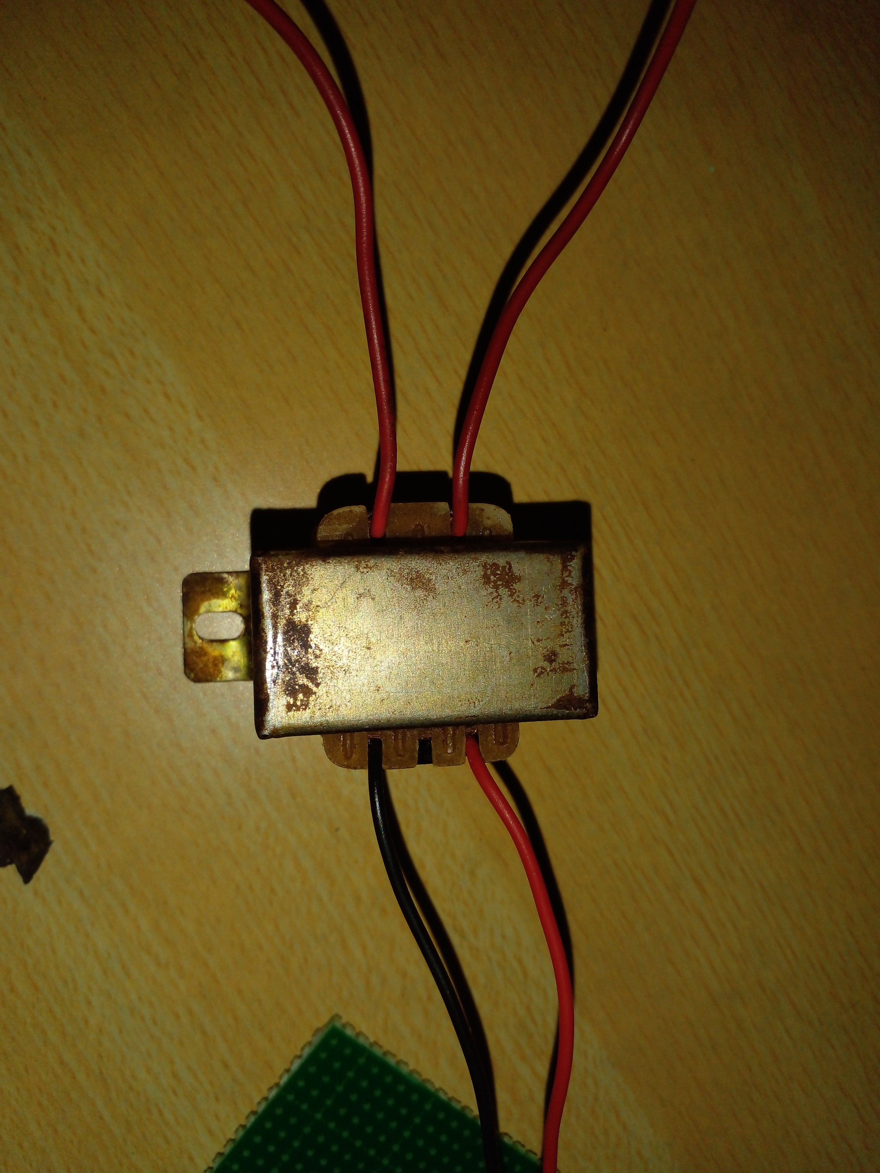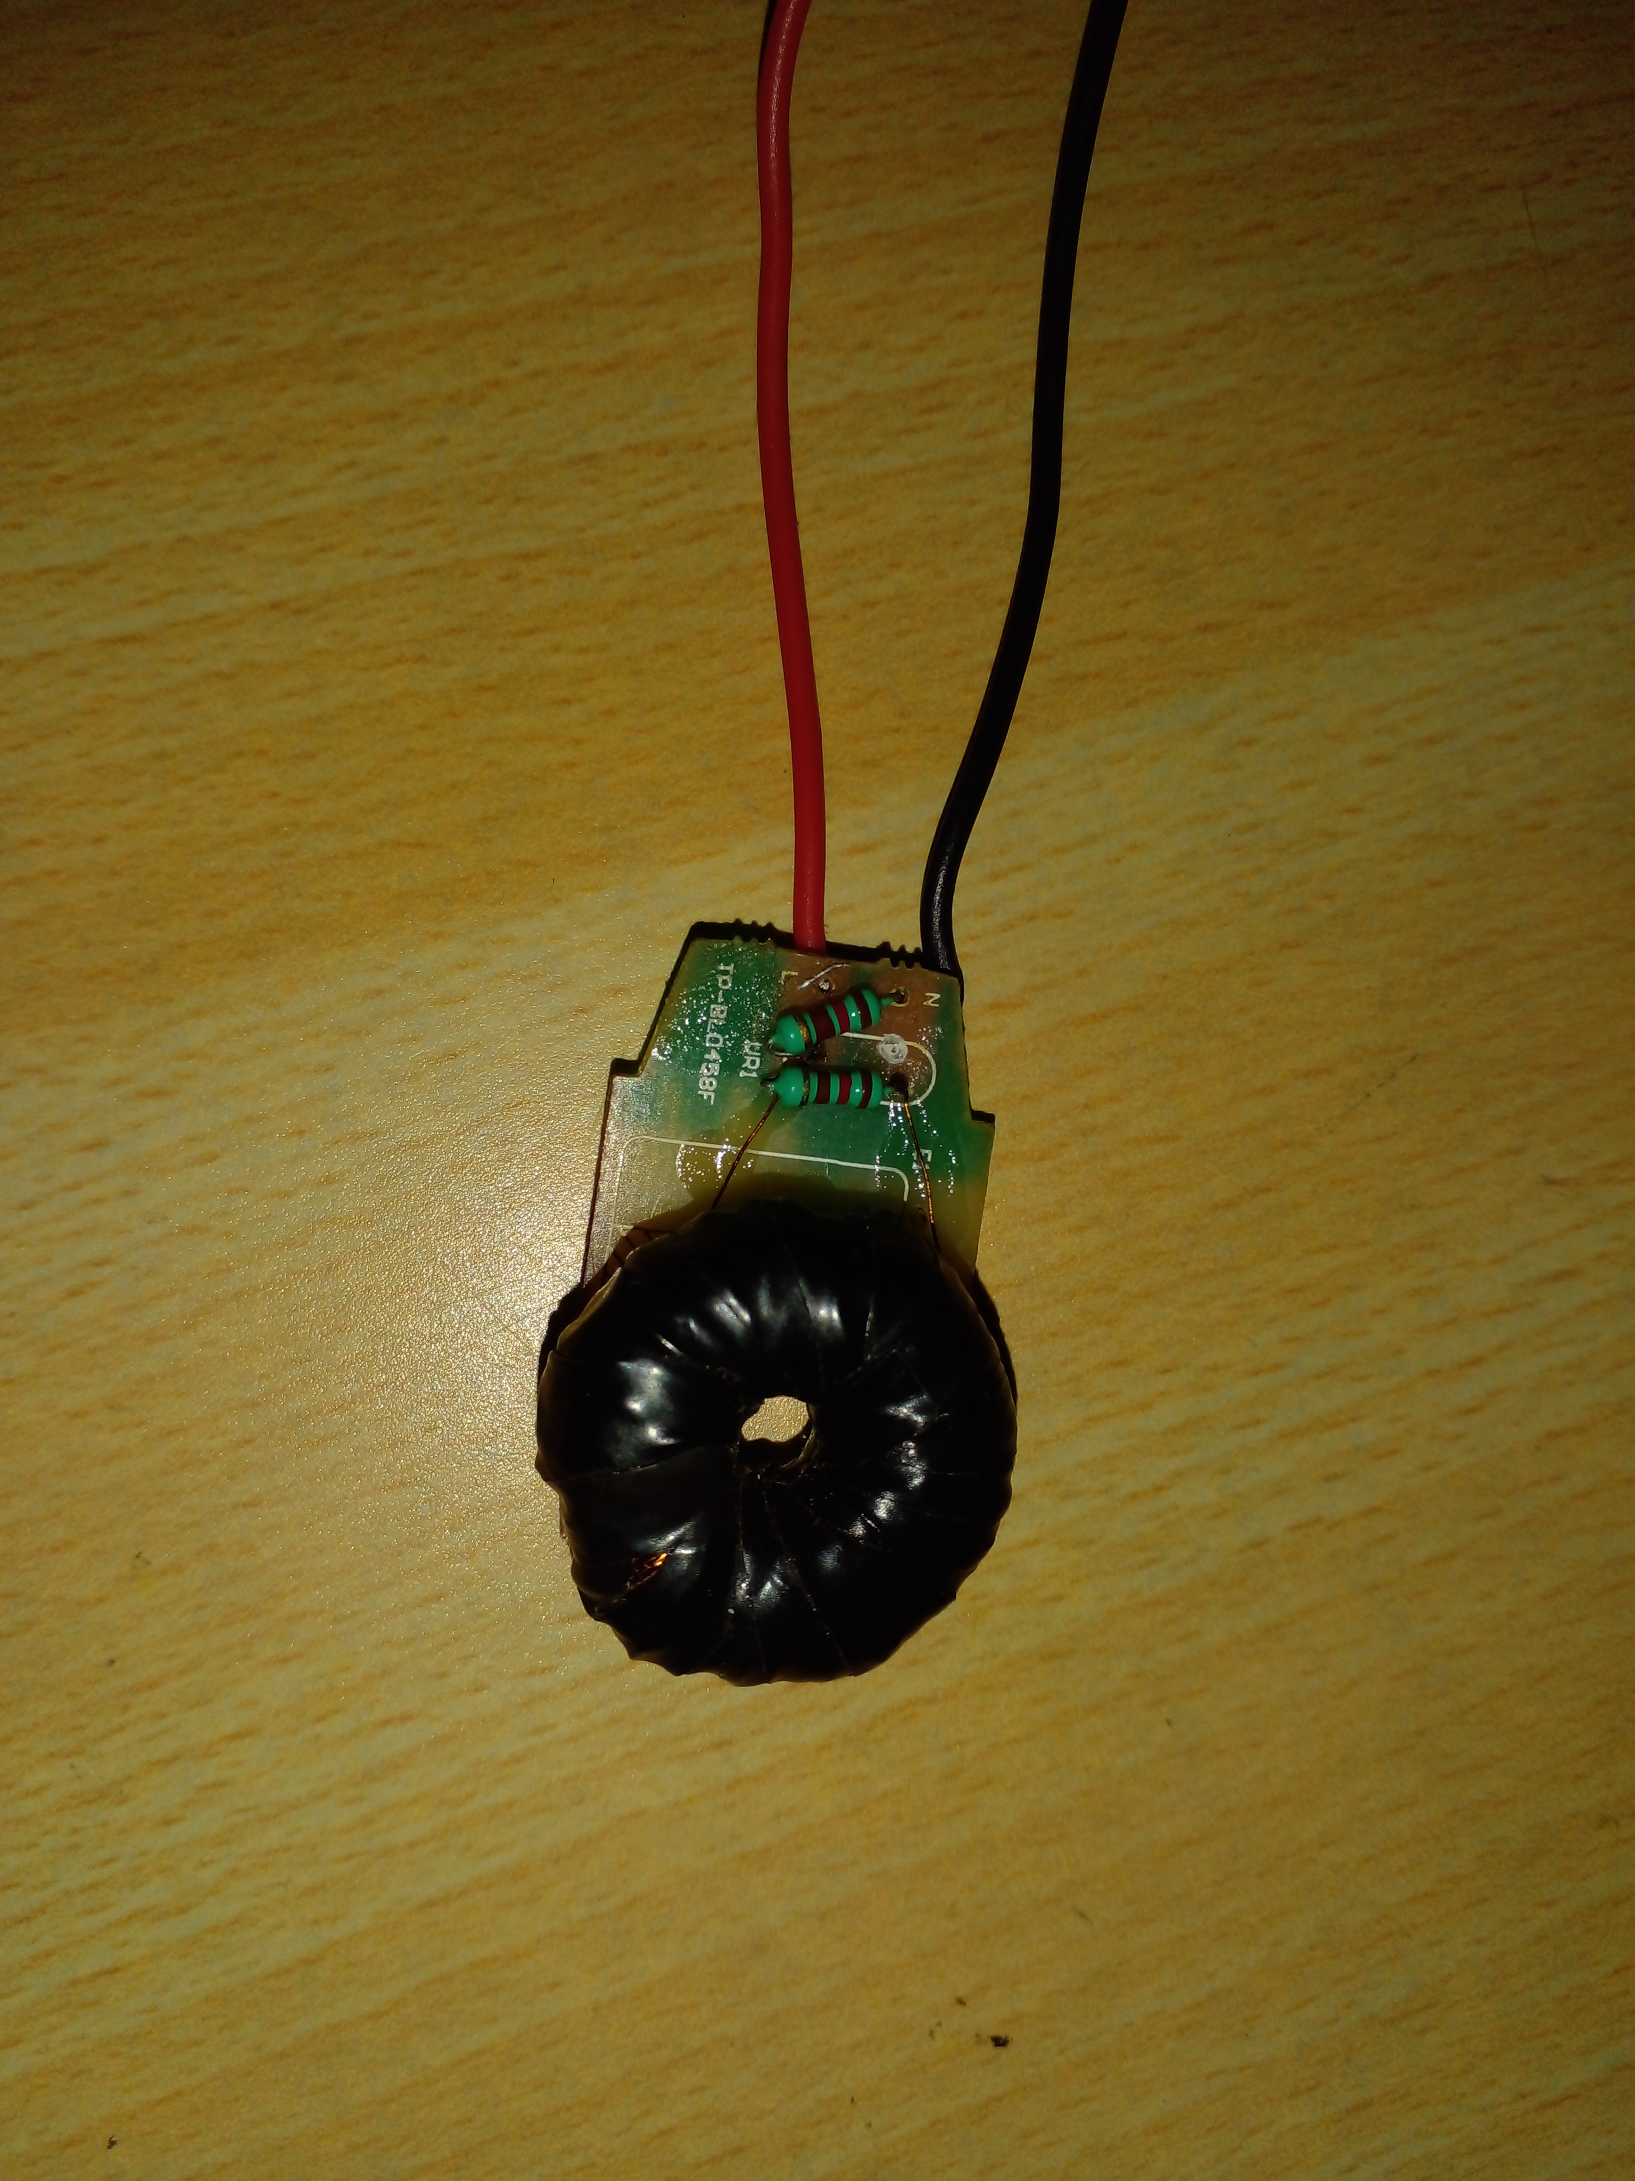

**Potential transformer**

**Current transformer**

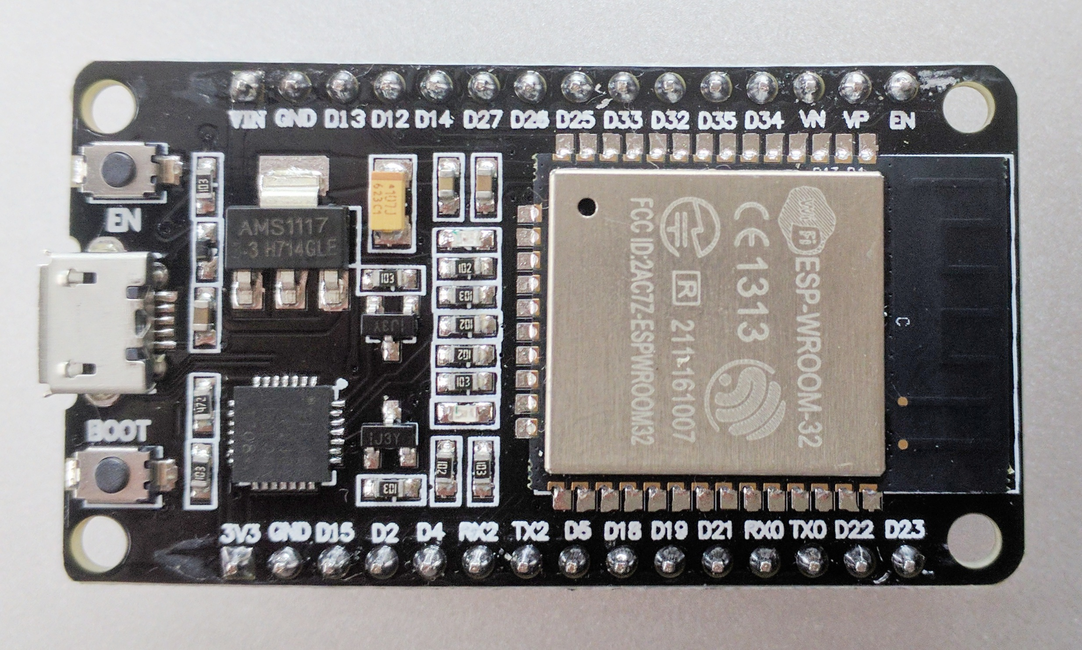

**ESP-WROOM-32 DEVKIT V1**

**4.4 Assembling Project**

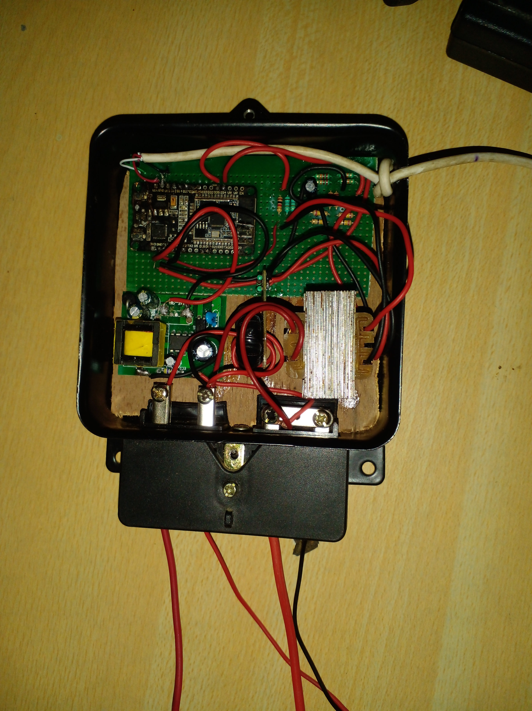

## Coding microcontroller for a project

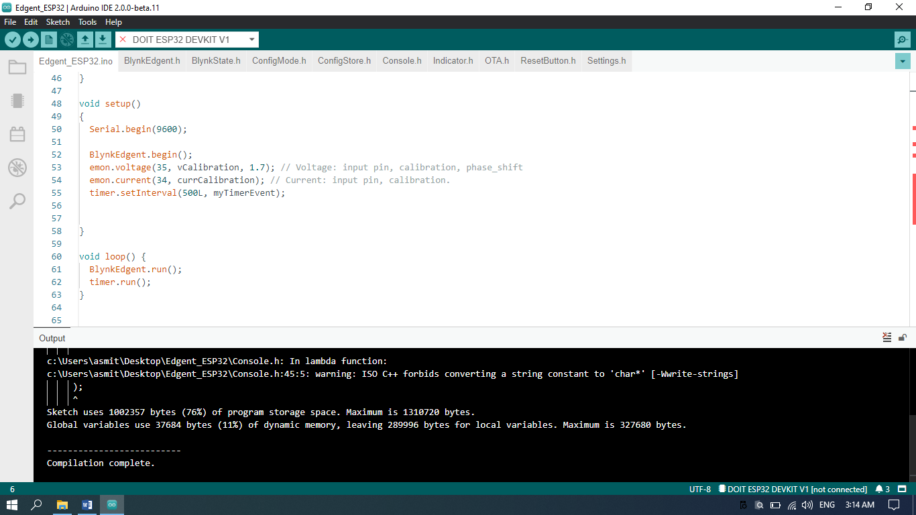**An error occurred and after correcting error and Recompiling:**

## Testing and calibrating the output of the project

**4.6 Testing and calibrating the output of the project**

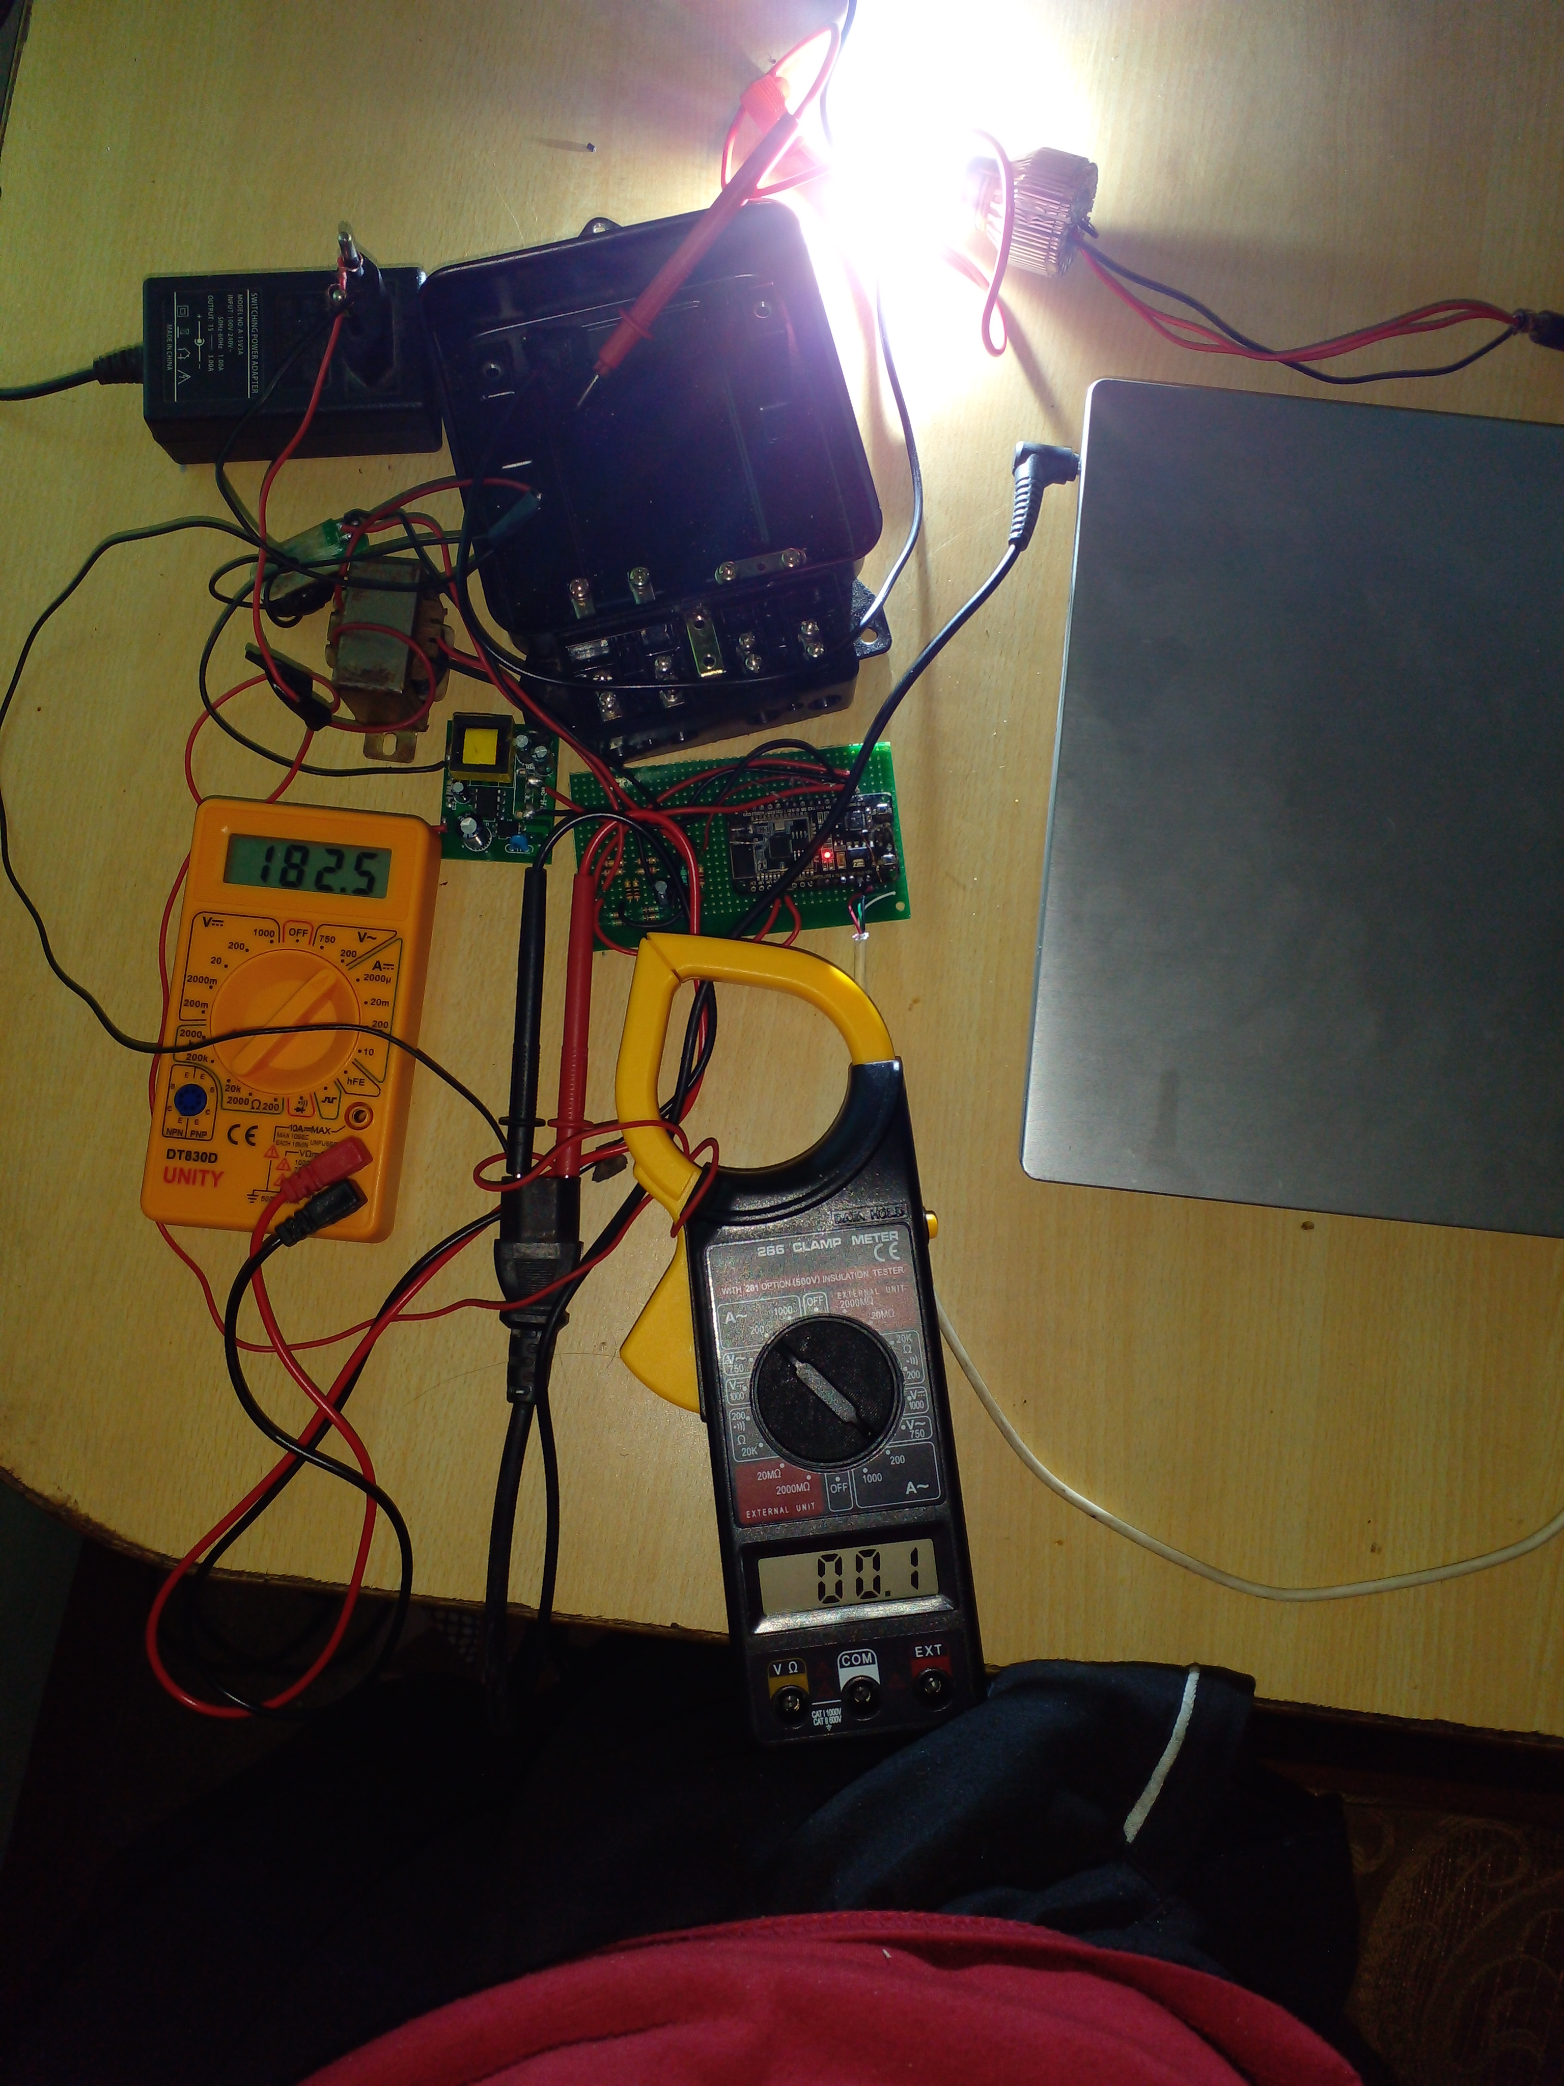

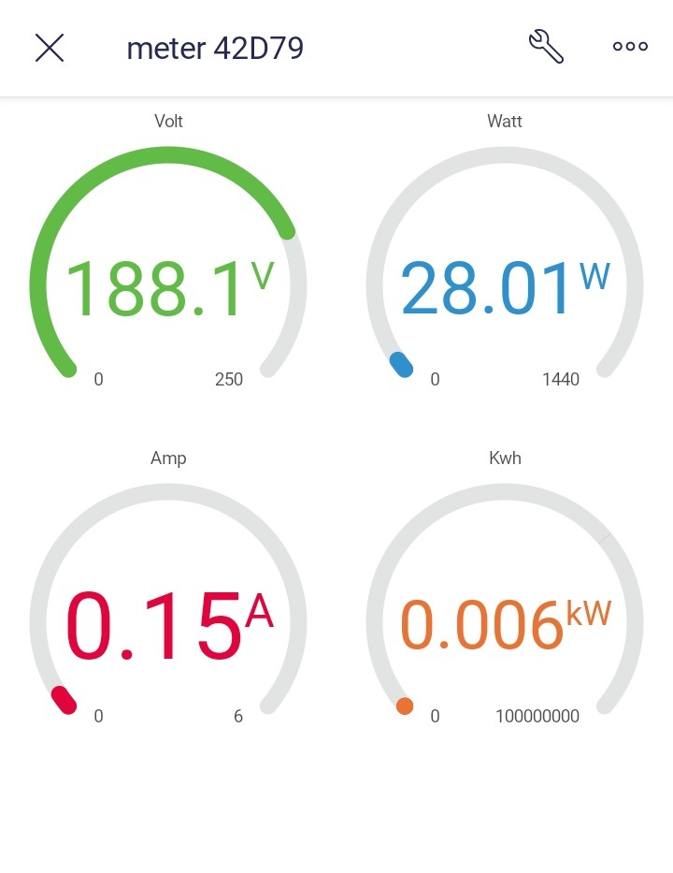

# 

# Appendix

## List of Abbreviations

IOT= Internet of Things

PCB= Printed Circuit Board

AC= Alternating Current

DC= Direct Current

I= Current

V= Voltage

R= Resistance

C= Capacitance

KW= KiloWatt

A= Ampere

W= Watt

RISC V= Reduced Instruction Set Computer Five

TSMC= Taiwan Semiconductor Manufacturing Company

CT= Current Transformer

PT= Potential Transformer

GND= Ground

KB= Kilobyte

SRAM= Static Random Access Memory

BLE= Bluetooth Low Energy